Internship Report for the IASAJ Judge Exchange Program

Selected by the International Association of Supreme Administrative Jurisdiction, I participated in the judge exchange program from November 19 to December 2 in 2023 at the Council of State of the Republic of Türkiye .

During my visit, I met with Mr. Kemal AçIKGÖZ, the Secretary-General of the Council of State of the Republic of Türkiye , and visited the Third Chamber and the Tenth chamber of Council of State of the Republic of Türkiye, etc. During the visit, in addition to visiting relevant institutions, I attended the hearing of a series of cases triggered by Türkiye's withdrawal from the Istanbul Convention. In addition, I also communicated with many judges of Council of State of the Republic of Türkiye.

**1. Basic judicial system in Türkiye**

Türkiye is a transportation hub in West Asia and the Middle East by sea, land and air and an important country in the Middle East and the Islamic world. The Republic of Türkiye was founded in October 1923. Since then, Türkiye has established the policy of separation of church and state. Today's legal system of Türkiye is the result of a series of reforms in politics, economy, culture and law of Türkiye in the early days of the Republic, from 1926 to 1938, under the leadership of Kemal, the "father of Türkiye". While implementing the policy of separation of church and state, Türkiye established the Grand National Assembly in 1936 and began to implement democratic elections. The first Constitution of Türkiye stipulates the principle that Türkiye is "a non aligned country under sovereignty". After the founding of the Republic of Türkiye, it absorbed the outstanding parts of the western legal system and formulated relatively perfect written laws.

According to the law, Türkiye adheres to the principle of judicial independence. It also implements a dual track system, that is, it is divided into two major systems: ordinary courts and administrative courts, which are independent of each other. Among them, ordinary courts are responsible for handling criminal and civil cases, while administrative courts are responsible for handling administrative cases. The ordinary courts in Türkiye are divided into three levels, namely the primary court, the regional appellate court and the Supreme Court of Appeal, which is responsible for hearing civil and criminal final disputes. Civil primary courts include civil first instance courts, commercial courts, family courts, labor courts, intellectual property courts, maritime courts, etc. The criminal first instance court includes criminal first instance court, intellectual property criminal court, serious crime court, juvenile criminal court, public security court, etc. Administrative courts are also divided into three levels, namely regional courts, provincial courts, and the Supreme Administrative Court. Under the influence of the European Court of Human Rights, Türkiye has created the Constitutional Court to deal with human rights disputes and the constitutionality of the actions of government agencies. In addition, similar to France, Türkiye also has a dispute court with jurisdiction. Since Türkiye's administrative court and ordinary court do not have a common superior court, in order to resolve the conflict of jurisdiction between the administrative court and ordinary court, the jurisdiction dispute court came into being.

**2．The Development History and Functions of the Council of State of the Republic of Türkiye**

**2.1 the history of the Council of State of the Republic of Türkiye**

The foundations of the Council of State are based on the Assembly of Vala-yi Ahkami Courthouse, which was founded by Sultan Mahmud Il in 1838. At that time, the Council of State functioned almost as an advisory council, a preliminary parliament.Sultan Abdulaziz, during his official visit to France in 1867, pioneered the idea of establishing a Conseil d'Etat - like assembly in the Ottoman Empire by studying the French state system, personally dealt with the formation of the State Council and chaired its establishment meetings.

The Council of State took its place in the legal system on May 10, 1868, when Sultan

Ab-dulaziz's famous speech, which also touched on the principle of separation of powers, was read by Grand Vizier Mehmet Emin Ali Pasha at Bab-i Ali, with the name of the State Council. The establishment of the State Council was a driving force in the Ottoman Empire that accelerated the development of modern state thought and the renewal movements that began in the first half of the 19th century. The fact that the institution building is located right in the middle of Bab-i Ali, the government center of the Ottoman Empire, between the ministries of Interior and Foreign Affairs, and the appointment of Mithat Pasha as its Founding President emphasizes the importance attributed to the State Council.

The duties of the institution are determined with a fourteen-item ordinance. The duties included "examining draft laws, statutes, judging civil officers, informing the sultan and the ministers about everything if they request". The State Council was divided into five departments: the Civil Service, the Public Works, Justice, the Education and the Finance, each of which has a president and ten members. After serving for fifty-four years during the Ottoman Empire, the State Council continued to function within the Government of the Turkish Grand National Assembly when all the central institutions in Istanbul were placed under the administration of the TONA on November 4, 1922.

While emphasizing the importance and role of the Council of State in the history, Mustafa Kemal Atatürk used the following statements: "Since the Council of State is an important institution related to the administrative and economic life of the country, I would like to wish that the draft law prepared by the Internal Affairs Commission of the supreme Assembly, would be formed as soon as possible to address the growing need for the Council of State from the administrative branches of government and that it would be enacted in a way commensurate with the need."

The Council of State, whose organization was reorganized by Law No. 669 issued on July 6, 1927, was institutionalized with its new structure. The organization and organization chart has been classified by the names of Reorganization, Civil Service, Finance - Public Works and Deavi and has been established as three administrative and one trial chambers. The Council of State, included in the constitutions of 1924, 1961 and 1982, by the establishment of the regional administrative, administrative and tax courts, which are the first-instance administrative judicial authorities, in addition to its advisory role, it also gained the title of the high court as an appellate authority in 1982.

As result of the appeal law introduced by Law No. 6545 of June 18, 2014 that was actually effective on July 20, 2016, the existing two-degree trial system in the procedure of administrative justice has been transformed into a three-degree system in terms of disputes in the Law. In addition, with the amendment made to the Constitution by Law No. 6771, the military administrative jurisdiction was abolished and it was decided the files at the stage of reviewing the existing law in the Military Supreme Administrative Court to transfer to the Council of State. Then, with the abolition of the military administrative judicial path, administrative judicial activity is now carried out at one-hand.

Having a 155-year history, the Council of State has been instrumental in the formation of administrative judgements, the establishment of administrative law principle and the adoption of the rule of law, and has taken an indispensable place in the legal system.

**2.2 the duties of the Council of State of the Republic of Türkiye**

According to the constitution, the Council of State is the final examination body of decisions and provisions issued by administrative courts and which the law does not leave to another administrative jurisdiction. It also considers certain cases indicated by law as the first and last instance court. The Council of State is responsible for considering cases, informing about concession conditionals and contracts related to public services within two months, resolving administrative disputes and doing other work indicated by law.

The duties of the Council of State are specified in detail in the Law on the Council of State No. 2575 (Article 23). Accordingly, the Council of State;

1) examines and decides on appeals against decisions made by administrative courts and tax courts, as well as decisions on cases heard at the Council of State as a court of first instance. The duty of the Council of State as an appellate authority is limited to conducting an review of violations of the law that have arisen in the form of non-ap-plication or incorrect application of a rule of law.

2)decides administrative cases written in this Law as the first and last instance court.

3)gives opinion about concession conditionals and contracts related to public services.

4) performs the tasks assigned by this Law and other laws.

In this context, while the Council of State today resolves some cases as a court of first instance in the context of its judicial duties, and performs the duties of the appellate authority, it also fulfils the administrative duties assigned to it.

One of the judicial duties of the Council of State is to decide some cases as a court of first instance. As a court of first instance, the cases to be heard in the Council of State are listed in Article 24 of the said Law. According to this article, the Council of State decides the cases which includes the decrees of the President, Regulatory acts other than Presidential decrees issued by the President, regulatory acts issued by ministries and public institutions or professional organizations that are public institutions and that will be applied throughout the country, according to the actions and processes taken on the decisions made by the Administrative Law Chamber of the Council of State or the Administrative Affairs Board, Cancellation and full remedy actions that will be filed against the decisions of the High Board of Discipline of the Council of State and the actions of the Presidium of the Council of State related to the field of duty of this Board, administrative cases arising from concession conditionals and contracts related to cases falling under the jurisdiction of multiple administrative and tax courts and public services for which an arbitration route is not envisaged.

In addition, the Council of State examines and decides on the requests of municipalities and provincial special administrations that their elected bodies lose their titles as organs.

As an appellate authority, the Council of State examines and decides decisions made by regional administrative courts, administrative courts and tax courts, as well as decisions on cases heard at the Council of State as a court of first instance, by appeal. Although the Council of State stands out today as a high court conducting judicial re-view; it owes its name and its value in history to its advisory and review function, which is more secondary today. The First Chamber performs the administrative tasks assigned to perform this function.

The First Chamber examines the works given by Article 42 of the Council of State Law and other laws and makes a decision or expresses its opinion accordingly.

**2.3 the formation of the Council of State of the Republic of Türkiye**

**2.3.1. Organization Chart**

There are 113 professional members including the President of the Council of State, the Chief Prosecutor, Vice-Presidents, Presidents of Chambers and Members serving in the Presidency of the Council of State. In addition, the Council of State employs 393 examining judges to review case files, make the necessary statements to Chambers or Boards, prepare minutes and 44 prosecutors to give their thoughts on the merits in first-instance cases, and 1497 personnel to conduct administrative services.

**2.3.2 General Assembly**

The General Assembly of the Council of State consists of the President of the Council of State, the Chief Prosecutor, Vice-Presidents, Presidents of Chambers and Members, as well as the Secretary General.

**2.3.3 Chief Prosecutor**

The Article 60 of the Law on the Council of State regulates the duties of the Chief Prosecutor and the Article 61 regulates the duties of prosecutors. Accordingly:

The Chief Prosecutor, in his/her capacity as a court of first instance, assigns the case files considered at the Council of State to prosecutors according to the separation of office s/ he deems appropriate to inform his/her thoughts on the merits. S/He ensures that the thoughts are informed on time and that prosecutors and other officers working in the Chief Prosecutor's Office continue their duties and work diligently, takes the necessary measures to record and store incoming files and send those who have finished their work to the appropriate places without delay. S/He can apply for an appeal for benefit of the law at the request of the relevant ministries or ex-officio. Expresses an opinion on a dispute between administrative and judicial authorities about a duty or provision that has occurred.

The prosecutors examine the files referred to them on behalf of the Chief Prosecutor and give their opinions on the merits in reasoned and written form within a month.

If these periods are expired, they will report the situation to the Chief Prosecutor with their causes. It performs other tasks that the President of the Council of State and the Chief Prosecutor will give, adapts to the measures that the Chief Prosecutor will take to maintain working order and increase work efficiency. The prosecutors can demand all kinds of information from the relevant offices through the Presidency of the Council of State, as well as bring related process files. If it is deemed necessary by the chambers considering the cases, the prosecutors of the Council of State also state their opinions orally with prior notice. It is essential that prosecutors are present at the hearings of the first-degree cases heard at the Council of State.

There are forty-four prosecutors in the Chief Prosecutor's Office of the Council of State, one of whom is an administrative officer.

**2.3.4 Plenary Session of the Law Chambers**

There are two plenary sessions in the Council of State, one administrative and the other tax. The formation of these plenary sessions is regulated by the Board of Presidency for two years from each administrative law chamber; the Plenary Session of the Tax Law Chamber consists of the heads of tax law chambers and three principal and three substitute members appointed by the Board of Presidency for two years from each tax law chamber. At the end of the two-year term, by the Board of Presidency, half of the members on both sessions are reappointed for a period of two years, while the other half are renewed from the members who were not previously appointed to the plenary sessions. The original members appointed to the plenary sessions may be appointed for a maximum of two consecutive terms. If the original member is unable to perform his/her duties temporarily, a substitute member is appointed from the relevant chamber and, if necessary, from other chambers participate in the meetings of the plenary sessions. In case of vacancy in the original or substitute memberships of the sessions, a new member shall be appointed by the Board of Presidency within several days to complete the remaining period.

The plenary sessions are headed by the President of the Council of State or one of the deputies, and in their absence, by the most senior of the chamber heads. The sufficient number of meetings and interviews is fifteen for the Administrative Law Chamber and eleven for the Tax Law Chamber. Those who have participated in the decision in these offices cannot be on the administrative or tax law chambers in the examination of decisions made by administrative law courts and tax law courts as a court of first instance by appeal or appeal and in the examination of decisions made at a meeting of the two chambers together.

If the participants in these meetings are an even number, the least senior member cannot join the chamber. In these chambers, decisions are made by a plurality of votes.

In the provisional Article 24 of the Law of the Council of State, the formation and working procedure of the Plenary Session of the Administrative Law Chambers has been additionally regulated until 31/12/2022. According to this regulation, the Plenary Session of the Administrative Law Chambers consists of fourteen members appointed by the Board of Presidency, provided that there is at least one member from each administrative law chambers. The Chambers is chaired by the President of the Council of State or one of its deputies, and in the absence of these, the most senior member of the Session.

These members serve on the Plenary Session of the Administrative Law Chambers on an ongoing basis. However, taking into account the workload situation, it may be decided by the Plenary Session that members participate in the work of the chamber. The sufficient number of meetings and quorum is eleven. Decisions are taken by a majority of votes of the participants of the meeting.

Article 38 of the Council of State Law lists the duties of the law chambers, Accordingly, the Plenary Session of the Administrative Law Chambers considers the insistence decisions made by the administrative courts and the decisions made by the administrative law chambers as a court of first instance; the Plenary Session of the Tax Law Chambers, on the other hand, is responsible for reviewing the insistence decisions made by the tax courts and the decisions made by the tax law chambers as a court of first instance on appeal.

In addition, Plenary Sessions of the Law Chambers decide on requests to resolve discrepancies and disputes between the decisions of the Regional Administrative Courts in accordance with Article 3/C of the Law No. 2576 on the Establishment and Duties of the Regional Administrative Courts, Administrative Courts and Tax Courts. The Plenary Session of the Administrative Law Chambers consists of the Vice-President, fourteen members, twenty-one rapporteur judges and the registry. The Plenary Session of the Tax Law Chambers consists of the Vice-President, sixteen members, six rapporteur judges and the registry.

**2.3.5 Chambers**

It is stated in the Article 13 of the Law of the Council of State that the Council of State consists of a total of ten chambers, one of which is the administrative chamber and nine of which is the law chambers. The Third, Fourth, Seventh and Ninth chambers of the law chambers serve as the tax law chambers, and the others serve as the administrative law chambers.

Each chamber has a president and enough members. The chambers work with the participation of a president and four members and decide by absolute majority. If the number of members is sufficient, more than one chamber can be created. In this case, the other chambers created are headed by the most senior member of the chamber. Negotiations are held in secret. There are enough rapporteur judges in the chambers.

In each chamber there is a clerk under a manager of registry. They carry out writing and notification affairs.

The duties of the First Chamber, which is the only administrative chamber of the Council of State, is determined in the Council of State Law (Article 42), and the administrative law chambers and the tax law chambers work among themselves on the basis of the division of labour. Law chambers is determined by the Board of Presidency. The principles that the Board of Presidency will follow when determining the division of labour are set out in the Article 27 of the Council of State Law.

Within the framework of these principles, the division of labour determined by the decision of the Board of Presidency of the Council of 51, 202ated January 18, 12, 2020 and numbered 2020/62 was implemented as of January 1, 2021.

**A. First Chamber**

The First Chamber of the Council of State considers and decides on and gives opinion on concession agreements and contracts related to public services, requests for opinions that are written in the laws that will be received from the Council of State, disputes arising from the application of the thirtieth article of the Expropriation Law, in accordance with the Law on the Special Provincial Administration, the work assigned to the Council of State directly or by appeal, works that have been submitted to the Council of State by the Municipal Code and are not the subject of administrative proceedings, proposals of associations to be made in order to be considered as associations working in the public interest, the work of public officers and other public officials to be performed in accordance with the legislation on their trial.

The First Chamber of the Council of State consists of the President of the Chamber, five members, thirteen rapporteur judges and the registry.

**B. Second Chamber**

The Second Chamber of the Council of State is tasked with resolving the following cases and appeals; the appointment, transfer (including consent procedures), discipline, registry, performance, achievement, evaluation of outstanding achievement and reward and termination of duty due to loss of any of the conditions for admission to the public service during the civil service, as well as the rank and promotion of members of the security and gendarmerie services class for public officers working in the Ministry of Internal Affairs and its affiliated, related and relevant organizations of this Ministry; from the legislation on family practice including the right to conclude contracts, renunciation, issue warnings, monetary issues and a burial license granted to family practices by the Law No. 1593 on Public Health Law); except for the teaching staff of higher educational institutions; from the work arising from the legislation on public officials, which falls outside the duties of the Fifth and Twelfth Chambers of the Council of State; from the procedures related to the request for adequate pay and eviction established in accordance with the Public Procurement Law; from the Law No. 3572 on the Amendment and Adoption of the Decree Law on Opening and Working Licenses of the Workplace (including the work places within the scope of the Law and the Directive on Opening and Working Licenses and Transactions established in accordance with the Law No 486 of April 16 1340 on General Municipality and Some Articles of the Law No.1608 on the Criminal Penalties of the District); Law No. 2559 on Police Duties and Security; Law No. 5179 on the Adoption by Amendment of the Decree Law on the Production, Consumption and Review of Foodstuffs; Veterinary Services Phytosanitary, Food and Feed Law No. 5996; Metropolitan Municipality Law No. 5216; Municipal Code No. 5393; Decree Law No. 552 on the Regulation of the Trade in Fresh Vegetables and Fruits and their Wholesale Status; Law No. 5957 on the Regulation of Trade in Vegetables and Fruits and Other Goods with a Sufficient Depth of Supply and Demand, and transactions related to business opening and work permits established in accordance with the Municipal Income Law No. 2464 (except taxes, pictures, fees) and administrative fines imposed on workplaces, for actions related to the inspection, evacuation, prohibition of activities, temporary or indefinite closure of workplaces; it is responsible for resolving cases and appeals arising from administrative and judicial fines issued by administrative and judicial authorities, as well as collection proceedings and administrative sanctions decisions, which are outside the purview of other trial chambers, except for the chambers that handle tax cases.

The Second Chamber of the Council of State consists of the President of the Chamber, nine members, thirty-one rapporteur judges and the registry.

**C. Third Chamber**

The Third Chamber of the Council of State is responsible for examining and making the decisions on appeals against decisions made by the tax law chambers of the Gaziantep Regional Administrative Court regarding income, institutions and value added taxes (excluding vat on import), the tax courts that resolve cases to which the tax authorities of the Anatolian Side of Istanbul are parties, and the tax law chambers of the Istanbul Regional Administrative Court that review decisions made by the tax courts of Bursa, Edirne, Kocaeli, Sakarya, Tekirdag by appeal. However, it also resolves issues related to tax, duty, fee and similar financial obligations that are outside the duties of other tax law chambers.

The Third Chamber of the Council of State consists of the President of the Chamber, five members, nineteen rapporteur judges and the registry.

**D. Fourth Chamber**

The Fourth Chamber of the Council of State examines and decides on the decisions of the President and the Council of Ministers regarding income, institutions and value added taxes, as well as cases against other regulatory acts.

This chamber also resolves appeals made against decisions made by the tax law chambers of the Istanbul Regional Administrative Court, which conducts an appeal review of decisions made by the tax law chambers of the Ankara Regional Administrative Court and the tax courts that resolve cases to which the tax offices of the European Side of Istanbul are parties in relation to income, corporate and value added tax . The Fourth Chamber of the Council of State consists of the President of the Chamber, six members, twenty-seven rapporteur judges and the registry.

**E. Fifth Chamber**

Fifth Chamber of the Council of State considers the matters related with the Law No. 6087 No. 2802 on judges and prosecutors High Council of judges and prosecutors to be established in accordance with the law written examination and interview, candidate status and to the profession through the process, including admission procedures and disciplinary procedures); for the state of emergency declared by the Council of Ministers Decree and the decree on measures taken under the state of emergency regarding verbatim or modified with the law that was adopted, and for examining cases and appeals arising from transactions established under Temporary Article 35 of the Legislative Decree No.375.

The Fifth Chamber of the Council of State consists of the President of the Chamber, six members, thirty-four rapporteur judges and the registry.

**F. Sixth Chamber**

The Sixth Chamber of the Council of State resolves cases and appeals arising from requests for preparation and implementation of plans of all types and sizes in accordance with the Zoning Law and other laws and relevant legislation, arrangement of land and field plots, division and unification works, zoning status, from transactions established together with the plan or separately against licensing and expropriation transactions; implementation of environmental (including project process), straits, antiquities, slums, coastal and tourism legislation; sealing, suspension, demolition decisions from the collection of fines and penalties in relation to the processes established in accordance with the zoning code and other laws and related legislation; from the legislation on disaster affairs; compensation for damages caused by earthquakes, landslides and other natural disasters based on the principles of service defect or perfect liability arising from the application of zoning legislation.

The Sixth Chamber of the Council of State consists of the President of the Chamber, eleven members, fifty-four rapporteur judges and the registry.

**G. Seventh Chamber**

The Seventh Chamber of the Council of State is responsible for resolving cases related to customs and import duties, excise duty, expenditure taxes, motor vehicle tax, succession and inheritance tax, as well as examining appeals related to them.

The Seventh Chamber of the Council of State consists of the President of the Chamber, six members, twenty-one rapporteur judges and the registry.

**H. Eighth Chamber**

The Eighth Chamber of the Council of State is tasked with resolving cases and appeals arising from the following; legislation related to village, municipal and private administrations including disputes arising from the Pasture Law No. 4342 and the Local Government Associations Law No. 5355); due to the fact that the bodies of local administrations that have come up for election have lost their titles as organs; from the housing legislation; from mining, quarrying and forestry legislation (including works related to geothermal resources and natural mineral waters); from the legislation on professional organizations that are public institutions; student and student affairs; higher education legislation (including dismissal, discipline and personal affairs of teachers), legislation on private educational institutions; from the Law No. 278 on the Scientific and Technological Research Council of Türkiye and Some Regulations; highways traffic and highways transport legislation (including legislation on motor vehicle driving courses).

The Eighth Chamber of the Council of State consists of the President of the Chamber, seven members, thirty-two rapporteur judges and the registry.

**I. Ninth Chamber**

The Ninth Chamber of the Council of State resolves appeals before the tax law chambers against decisions made by Adana, Erzurum, Izmir, Konya and Samsun Regional Administrative Courts regarding income, institutions and value-added taxes (excluding vat on import). The Chamber is also responsible for resolving cases and appeals related to stamp duty, property tax, village, municipal and private administration taxes, pictures, fees and shares, as well as their other income and tariffs, the Law on Fees.

The Ninth Chamber of the Council of State consists of the President of the Chamber, six members, twenty-two rapporteur judges and the registry.

**J. Tenth Chamber**

The Tenth Chamber of the Council of State decides cases and appeals arising from the Law No. 3093 on Revenues of the Turkish Radio and Television Institution; from the Public Health Law No. 1593; from the Law No. 4703 on the Preparation and Implementation of Technical Legislation on Products, from the Financial Leasing Law No. 3226, from the Legislative Decree No. 90 on Lending Money and Law No. 6361 on Leasing, Factoring and Financing Companies.

The Tenth Chamber also resolves the following cases and appeals; the border and land acquisition legislation, (including immovable property of companies with foreign capital and limited acquisition of real rights); the Law No. 5233 on the Compensation of Damages Arising from Terrorism and the Fight against Terrorism; the health legislation that falls outside the duties of other administrative law chambers; full jurisdiction disputes related to health care; pension and public officers social insurance and general health insurance legislation, except for pension legislation (including administrative fines and Application Notification for Treatment Assistance); from the transactions established in relation to bank promotional payments; from the legislation on consumer protection (including administrative fines and other administrative sanctions); from the legislation on weapons and knives; transactions established in accordance with customs legislation about customs consultants and assistant consultants, as well as disputes that fall outside the duties of other law chambers, with the exception of law chambers dealing with tax cases.

The Tenth Chamber of the Council of State consists of the President of the Chamber, six members, thirty-one rapporteur judges and the registry.

**K. Twelfth Chamber**

The Twelfth Chamber of the Council of State resolves cases and appeals arising from the appointment, transfer (including assent procedures), registration, performance, achievement, evaluation of outstanding achievements and awarding procedures for public officials working in the Presidency and the Ministry of Justice and their affiliated related and relevant organizations; recruitment of public officials (including termination of office due to the subsequent understanding that there are no conditions for obtaining public office), progression of ranks, elevation of degrees, length of service, educational status and other adjustment jobs, as well as transactions related to their monetary rights; the actions related to the status and process of candidacy (including termination of office, disciplinary penalties, track record and success assessment); for actions related to disciplinary actions; failure to renew the contract established about public officials, termination of the contract, dismissal, termination of the post due to the loss of any of the conditions for admission to the civil service during the civil service from the work that falls outside the duties of the Second and Fifth Chambers of the Council of State; the Articles 4 / C and 4/D of the Law on Public Officers No. 657 on transactions related to employees (including contract-making, termination and monetary issues).

The Twelfth Chamber also resolves cases and appeals arising from the pension legislation of public officers; legislation on public officers related to privatization practices (including the re-employment of those who are unemployed as a result of privatization practices and disputes arising from transactions related to this issue); working hours and permits of public officers, as well as social rights and benefits; primary school teachers Health and Social Assistance Fund legislation; cases arising from the legislation repealed by No. 3320 and the case of public housing and housing assistance to pensioners with workers about their officers be provided with housing assistance payment to beneficiaries about making the law the Law No. 5664; No. 3417 Employees Saving Incentive Act and repealed law No. 4853 on Liquidation of the Employees Saving Incentive Ac-count, and the payments to be made from this account, and the Law No. 2330 On Cash Compensation and Allowance.

The Twelfth Chamber of the Council of State consists of the President of the Chamber, six members, thirty-one rapporteur judges and the registry.

**L. Thirteenth Chamber**

The Thirteenth Chamber of the Council of State resolves cases and appeals on the Law on the Protection of Competition; Law on Privatization Practices; The Law on the Regulation of the Market of Tobacco, Tobacco Products and Alcohol, The Sugar Law; Radio Law, Telegraph and Telephone Law and Electronic Communication Law; Universal Service Act; the Law on the Construction of Certain Investments and Services within the Framework of the Build-Operate-Transfer Model; the Law on the Establishment and Operation of Electric Power Generation Facilities with the Build-Operate Model and Regulation of Energy Sales; Law on the Assignment of Organizations other than the Turkish Electricity Authority for the Production, Transmission, Distribution and Trade of Electricity; Electricity Market Law, Natural Cas Market Law, Petroleum Market Law, Liquefied Petroleum Gas (LPG) Market Law and the Law on Amendments to the Electricity Market Law; Capital Market Law; Legislation on the Protection of the Value of Turkish currency; Obsolete Banks Law and Banking Law; the Law on the Restructuring of Debts to the Financial Sector and Amendments to Some Laws; the Law on the Establishment and Broadcasting of Public Radio and Television, as well as the Law on the Establishment and Broadcasting Services of Radio and Television; the Public Procurement Law, the Law on Public Procurement Contracts, the Law on State Procurement (except for disputes related to adequate pay and eviction) and tenders that are not subject to these Laws, as well as other tenders conducted by public institutions and organizations; the Law on the Use of Renewable Energy Sources for the Production of Electrical Energy, the Energy Efficiency Law; the Law on the Regulation of Publications Made on the Internet and the Fight against Crimes Committed Through These Publications; Decree Law on the Organization and Duties of the Public Oversight, Accounting and Auditing Standards Authority, the Law on the Sale of Alcohol and Alcoholic Beverages.

The Thirteenth Chamber of the Council of State consists of the President of the Chamber, nine members, thirty-seven rapporteur judges and the registry.

**3. Characteristics of administrative trial in Türkiye**

**3.1 Special Provisions on the Scope of Acceptance of Cases**

Article 125 of the Constitution of Türkiye includes a rule that "all administrative actions and acts may be subject to judicial review". Therefore, all types of administrative procedures and actions are subject to supervision by administrative courts. Of course, there are also some exceptions: domestic or international arbitration of disputes arising from franchise conditions and contracts related to public services with foreign-related nature; Appeal to the retirement decision made by the Senior Military Commission on the grounds of the absence of existing cadres; Decisions on the management and discipline of sports activities of sports federations can only be subject to mandatory arbitration; Litigation against the decision of the Supreme Election Commission; Appeal against the decision of the judge and prosecutor's committee (unless the decision involves dismissal of lawyers). According to the law, no judicial review shall be applied to the above decision.

According to the provisions of Article 2 of

Türkiye’s Administrative Procedure Law No. 2577, the types and scope of administrative cases accepted in Türkiye include but are not limited to: invalid lawsuits filed by people whose interests are infringed due to violation of the law in terms of authority, form, reason, subject and purpose; Direct relief lawsuits filed by individuals whose personal rights may be infringed upon by administrative actions and litigation procedures; Any disputes arising between the parties arising from the execution of any administrative agreement for a particular public service (except for those that specify franchise conditions and agreements). In judicial review of administration, the authority is limited to supervising whether administrative actions and procedures comply with the law. Of course, the law also stipulates that administrative courts cannot replace administrative agencies, that is, they cannot make judicial decisions in the form of administrative actions or administrative procedures, thereby limiting the powers enjoyed by the executive branch under the law and the authorization of the President. In addition, in

Türkiye's administrative procedure

and administrative trial system, there is no legal arrangement that specifically stipulates non litigation dispute resolution.

**3.2 Special Provisions on Review Methods**

The Administrative Litigation Law No. 2577 stipulates rules for reviewing administrative cases. In principle, the administrative court adopts a written hearing, and the hearing is an exceptional procedure that can only be conducted once if certain conditions are met. The parties shall submit their claims and defenses to the court in writing, and the administrative judge shall review the case file based on the documents. Administrative judges have an obligation to resolve disputes by inquiring with relevant individuals or institutions about all information and documents they believe to be true about the lawsuit. Unless in special circumstances, as long as the requested information or documents are not related to national security or significant national or foreign interests, the requirement to provide information and documents to the court must be met.

The administrative judge of Türkiye can access the identity data of the case parties through the database defined in the system, and can also use the national judicial network to share the data with judicial organs at all levels and administrative judicial organs, and consult the relevant case files on electronic media. Decree No. 2577 stipulates the procedure for administrative courts to conduct written hearings and review them through this document. For this reason, the evidence used by administrative judges to resolve disputes usually needs to be written. In addition, Law No. 2577 also stipulates that administrative courts have an obligation to review every point of disagreement when necessary. Therefore, individuals or institutions may be required to provide every information and document deemed confidential by the administrative court (except for the exceptions mentioned in the previous paragraph).

**3.3 Special Provisions on the Specialization of Courts**

The Constitution of Türkiye gives litigants the right to be guaranteed by the Constitutional Court. According to Article 36 of the Constitution, no court shall refuse to hear cases within its jurisdiction. Anyone has the right to file a lawsuit as a plaintiff. According to Article 37 of the Constitution, the principle of natural judgment, a decision to declare the removal of a person from the jurisdiction of a legally designated court is invalid. No one shall be tried by any judicial organ other than the court designated by law. The judicial authorities have a responsibility to conclude the trial as soon as possible at the lowest cost.

According to the Constitution of Türkiye and the Law of the Supreme Administrative Court, there are three levels of administrative justice in

Türkiye. Generally speaking, administrative and tax courts serving as the first instance courts conduct first instance reviews, while provincial higher courts conduct second instance reviews. In terms of the judicial organ of first instance,

Türkiye has not set up a special court. However, some issues can only be litigated in predetermined courts. For example, according to Article 111 of the International Law on Foreigners and the Protection of Foreigners No. 6458, which conducts judicial review of entry and exit decisions, if there is more than one first instance administrative court in the jurisdiction, the court with the jurisdiction number one shall be the competent court. Through this approach, specialized courts are established to handle individual professional matters, but in addition to these cases, these courts also need to continue to hear other disputes. In addition, according to Article 2, Paragraph 4 of Law No. 2576, the division of labor between the first instance court and the second instance court is determined by the High Committee of Judges and Prosecutors, and specialization is achieved through this approach. For example, appeals and first instance cases in the provincial high court caused by construction disputes are heard by the special department of the Supreme Administrative Court of Türkiye.

**3.4 Special Provisions on Emergency Trial Procedures**

In terms of the trial period, it is reported that

Türkiye has no relevant provisions on the trial period, but in order to improve the trial efficiency, Türkiye's laws specifically provide for "emergency trial procedures" and "judicial procedures related to central and joint review", which are exceptional and accelerated procedures, which are specifically stipulated in Articles 20/A and 20/B of Administrative Procedure Law No. 2577. Its purpose is to shorten the time for appealing to the court according to ordinary judicial procedures in emergency cases, and to quickly close the case according to its nature, closing the legal application channels for appealing to rulings (the mode of appeal is open).

Especially in shortening the appeal period, the Supreme Administrative Court is the highest authority that can make objections to the decision of the first instance court. According to Article 20/A of Law No. 2577, emergency procedures applicable to courts include tender emergency requisition procedures other than injunctions, decisions of the High Council for Privatization, sales, distribution, and lease transactions conducted under Law No. 2634, decisions made by the President to relocate due to potential disasters under Law No. 6306 and Law No. 2872, disputes arising from central and joint examination work and procedures, etc.

**3.5 Special Provisions on the Application of Law in Administrative Trials**

According to the law, Türkiye's administrative judges supervise the relevant administrative procedures in accordance with all regulations (including the Constitution, laws, regulations and international conventions) that have entered into force. The principle of rule of law, the principle of normative hierarchy, and Article 11 of the Constitution are the basic rules governing the application of judicial laws. Administrative and judicial organs, as well as other institutions and personnel, are not allowed to appeal to the Constitutional Court regarding the Constitution and conventions on fundamental rights and freedoms. When there are different provisions on the same matter, the provisions of international agreements take priority and cannot enforce secondary regulations, including opposing respect for international agreements on the grounds of violating the constitution. When the provisions on fundamental rights and freedoms that have officially come into effect are stipulated in international conventions, administrative judges should directly apply the provisions of the international conventions. Overall, administrative judges should conduct relevant compliance reviews and file lawsuits with the Constitutional Court in cases of unconstitutional or international agreement violations.

**3.6 Professional security of administrative judges in Türkiye**

According to the Law No. 2802 on Judges and Prosecutors, the recruitment examination for administrative judges in administrative courts is based on a written examination, and interviews are also required. Article 9/A of the aforementioned law provides detailed provisions on the scope and content of written and interview examinations. Those who pass the written test and interview will be arranged at the appropriate level, and those within the quota (required number) announced by the Ministry of Justice will be assigned to the position of administrative judge and begin their internship work. Individuals with a PhD in philosophy only need to undergo an interview.

Article 138 of the Constitution of Türkiye stipulates that judges shall perform their duties independently, and they shall make judgments in accordance with the Constitution, the law and their personal beliefs in line with the law. No authority, authority, office or individual shall issue orders or instructions related to the exercise of judicial power to courts or judges, send notices to them, or make suggestions or opinions. In the Legislative Assembly, no questions, debates, or statements may be raised regarding the exercise of judicial power in cases under review. Legislative and administrative organs should comply with court rulings. These authorities shall not make any modifications to the award, nor shall they delay the execution of the award.

Article 139 stipulates that judges and prosecutors shall not be dismissed or, unless requested by themselves, shall not retire before the age specified in the Constitution, nor shall they be deprived of their wages, allowances, or other rights related to their status, even if they are dismissed due to their court or position. The exceptions to the above provisions are those who have been convicted of crimes and dismissed, those who are unable to perform their duties due to poor health conditions, or those who have been determined to be unsuitable for continuing their profession, and their dismissal is not subject to the previous provisions.

Article 140 also stipulates that judges shall perform their duties in accordance with the principles of court independence and the guarantee of judge tenure. The qualifications, appointments, rights and obligations, salaries and allowances, promotions, temporary or permanent changes in their positions or workplaces of judges and prosecutors, the initiation of disciplinary proceedings and the implementation of disciplinary penalties and investigations against them, and subsequent decisions to be prosecuted for crimes committed, or to be convicted or dismissed for incompetence in the performance of their duties, as well as other matters related to their personnel status, should be regulated by law in accordance with the principles of court independence and the guarantee of judge tenure.

**3.7 E-gvernment Access**

E-government (e-Government Gate, Digital

Türkiye) is a web-based system that aims to deliver government services to citizens electronically, safely, uninterrupted and quickly through a common point, taking into account user needs.

By integrating the institutions and organizations responsible for performing public services into the e-Government Gate, it is ensured that the citizen's affairs with the State are carried out much faster.

In this context, a protocol on "e-Government Gate Service Integration" was signed on 18/11/2020 in order to provide the service to the citizen in the easiest and most effective way, in a quality, fast, uninterrupted and secure way by institution.

In 2021, the "Council of State File Inquiry" service was made available through the E-Government Gate, which allows people who are parties to the case files in the chambers and the plenary sessions of the Council of State to query the court information on the basis and decision number, opening date, subject, file type, parties to the case, file status (stage), decision result and date, place of origin, and the basis of the case files.

In addition to the mentioned services, the service of viewing the decisions made by the Council of State in the case files is provided through the UVAP Lawyer, Institution and Citizen Portals. In addition to the mentioned services, the service of viewing the decisions made by the Council of State in the case files is provided through the UVAP Lawyer, Institution and Citizen Portals. In addition, by placing the "Career Gate-Public Recruitment" tab, it was provided with the opportunity to apply from all over Türkiye via the e-Government for the personnel who will be employed at the Council of State.

**3.8 Sharing of decisions with the Public**

In accordance with the principle of legal security, it is expected that the Council of State, the supreme court of the administrative jurisdiction, will comply with previous decisions in similar cases. In order for this principle to be implemented properly, first of all, it is necessary to produce qualified and stable jurisprudence, and secondly, to disseminate these jurisprudence.

If the decisions of the Council of State are disseminated in a good way and understood correctly by everyone, it will be possible to ensure legal security and predictability, increase the accurate decision rate, open cases correctly and conclude them in a short time, reduce unnecessary litigation or legal remedies due to legal security and predict-ability, reduce workload and increase public confidence in the judiciary.

In accordance with the "Directive on the Publication of Decisions of the Chambers and Plenary Sessions of the Council of State", prepared for the purpose of anonymizing and publishing decisions made by the chambers and sessions of the Council of State, the "Decision Publication Bureau" was established on 06/02/2019.

Firstly, the Decision Publication Bureau reviewed the decisions published up to the date of the Bureau's operation and anonymized them within the framework of the procedures and principles set out in the Directive and published them in the "Precedent Decision Search" tab on the website of the Council of State. For this purpose, the Decision Publication Bureau, which continues its function, has been abolished as of 12/02/2020 and its duties have been envisaged to be performed by the Jurisprudence, Reporting and Statistics Unit.

As the number of published decisions is not considered sufficient, a structural change was needed and the "Directive on the Publication of Decisions of the Council of State" was repealed in accordance with Article 9 of the "Directive on the Publication of Decisions of the Council of State", which was published on the intranet page on 25/2/2020.

In accordance with this new Directive, which entered into force in 2020, it is connected with the rule that decisions made by the law chambers and the sessions of the Council of State are regularly published on the official website of the Council of State by the Jurisprudence, Reporting and Statistics Department, In this context, a total of 23,444 decisions were published until 25/2/2020, while 60,820 decisions were published between 25/12/2020 and 31/12/2021.

**4. Cases triggered by Türkiye's withdrawal from the Istanbul Convention**

On the morning of November 28, I attended the hearing hosted by the Tenth Division of the Supreme Administrative Court of Türkiye. Early in the morning, a large number of media and the public gathered outside the Council of State, either reporting on the hearing or introducing the views of their respective representative groups. The hearing attracted a lot of attention because in March 2021, Türkiye announced its withdrawal from the Istanbul Convention, and some public welfare organizations and women lawyers filed lawsuits against the withdrawal.

The Istanbul Convention, also known as the Council of Europe Convention on the Prevention and Suppression of Violence against Women and Domestic Violence, is the first convention in Europe aimed at combating violence against women and is also known as the "Convention against Domestic Violence". Initiated by the European Commission in Istanbul on May 11, 2011. The convention stipulates that domestic violence (including physical, gender, psychological, and economic violence), harassment and stalking, sexual assault, and forced marriage committed against women will face legal sanctions. The convention aims to establish a women's rights protection system with broad coverage and strict implementation standards, zero tolerance for sexual violence, and mandatory punishment for perpetrators. Action plans have been formulated in prevention, protection, and trial. Türkiye was the first country to sign and ratify the Convention. The convention officially came into effect in 2014 after the number of signatory countries reached 10. By 2019, 34 European countries, including Belgium, France, and Germany, had signed it.

Because it was a joint hearing organized by a series of cases, the parties and lawyers sat in every seat of the court where the hearing was held on that day. Due to the presence of many bystanders, the law enforcement officers had to temporarily move many benches. Throughout the hearing, lawyers strongly questioned the legality of Türkiye's withdrawal from the Istanbul Convention. Lawyers said that the current domestic laws of Türkiye are not so binding; Stresses the incidents of violence against women that have occurred throughout Türkiye, and reiterates the importance of acceding to the Istanbul Convention; Emphasize that the decision made by the court in 2022 is in violation of the Constitution of Türkiye, and the Istanbul Convention is the law to protect fundamental rights; The lawyers also criticized the Council of State for not contributing to preventing Türkiye from withdrawing from the international conventions, nor for protecting the LGBT group ; Lawyers also believe that withdrawing from international conventions will put Türkiye in an awkward position in the international community.

After the hearing, the judge accompanying me further introduced that in 2021, some officials of the Justice and Development Party, the ruling party led by President Erdogan of Türkiye, advocated the verification of the Istanbul Convention. They believe

that the Convention does not conform to

Türkiye's conservative values, encourages divorce, and destroys traditional family values. In addition, some officials believe that the convention to some extent encourages homosexual behavior. In March 2021, the Grand National Assembly of

Türkiye approved a bill aimed at combating violence against women, including that if the victims of violent crimes are women, the perpetrators will be punished more severely, and the continuous pursuers will be imprisoned. On July 18, 2022, the judges of the Council of State decided by a majority vote to reject the application against Türkiye's withdrawal behavior on the grounds that Türkiye has domestic laws regulating domestic violence, which also caused controversy.

Through the exchange and study in Türkiye, I realized that Türkiye's judicial system, especially the operation mechanism of the Supreme Administrative Court, has many unique features. Of course, they also face the contradiction of a sharp increase in the number of cases and fewer cases, which is similar to China. During this exchange of visits between judges, I also introduced China's judicial system, administrative trial system and the achievements of judicial reform in recent years, further strengthening the information complementarity and exchange between China and foreign administrative judiciary.

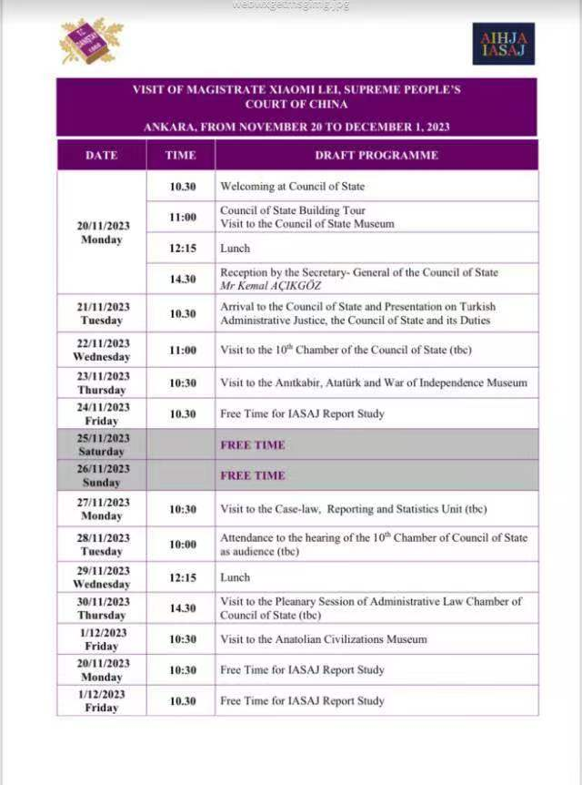

(program arranged by the Supreme Administrative Court of Türkiye)

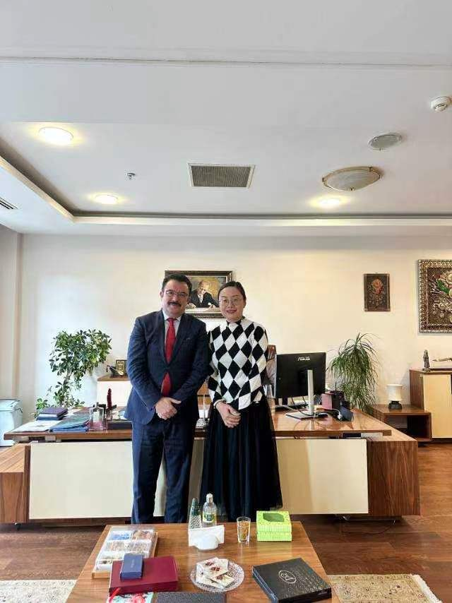

photo with the Secretary General of the Supreme Administrative Court of Türkiye

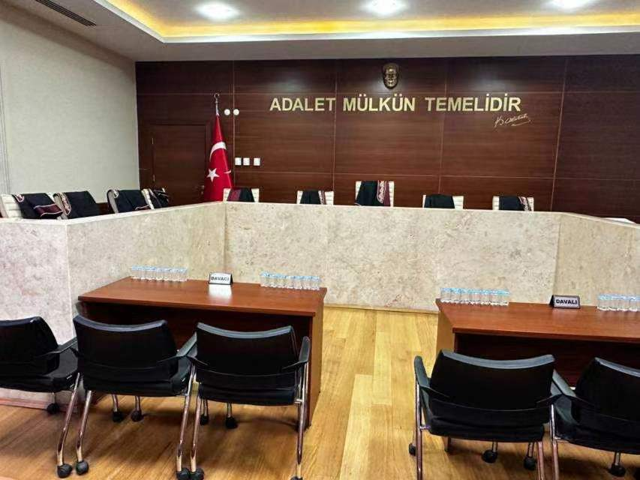

the court conducting a hearing on the withdrawal from the Istanbul Convention case

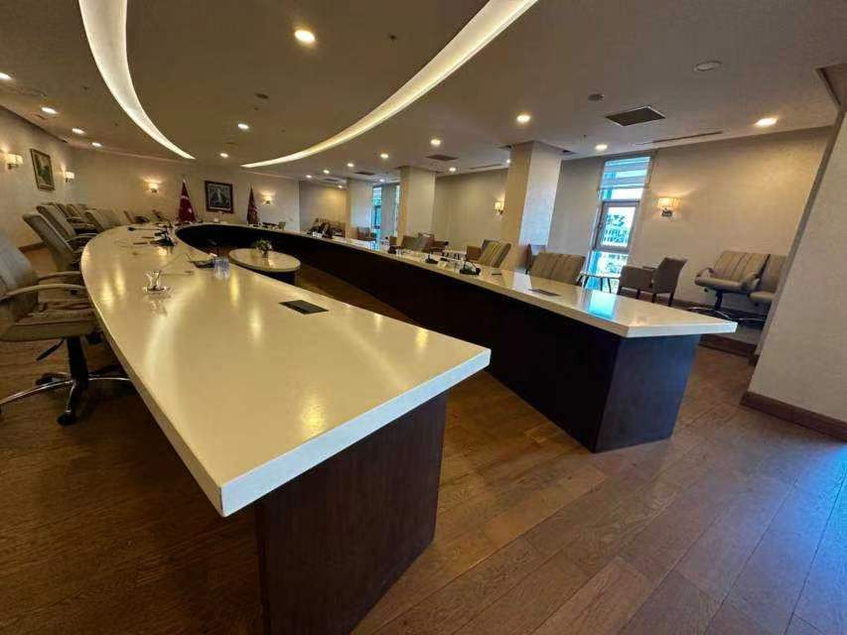

the conference room for convening the plenary session of the Administrative Law Chamber