Report on the Participation of Justice Uzi Vogelman in the Judicial Exchange Program of the IASAJ

Between 14.6.2018-28.6.2018, I participated in a judicial exchange program organized by the International Association of Supreme Administrative Jurisdictions (IASAJ). During that period I was hosted by the Italian Council of State.
I found the exchange both an insightful and enjoyable experience, thanks to the Italian judges' hospitality and their willingness to enlighten me about the Italian judicial system in detail.
The variety of activities organized by the Italian hosts were an opportunity to explore the Italian judicial system from different angles. The activities included:
- A meeting with the Council's President, Alessandro Pajno.
- A visit to The Court of Cassation, which included an in-depth discussion about the Italian legal systems and the role of different courts and tribunals.
- A meeting with Justice Anna Maria Verlengia of The Regional Administrative Tribunal of Rome, which included an introduction of the fundamentals of Italian Administrative Law.
- Participation in pre-hearing discussion and in a hearing of the Regional Administrative Tribunal of Lazio.
- Participation in discussions and hearings of several chambers of the Council of State, including an advisory tribunal. Each of the chambers had its own proficiency.
- Participation in a discussion with the professional staff of the Council for the Judiciary for Administrative Judges, and later on in a meeting of the Coucil.
The conversations I had with my Italian colleagues, allowed me to gain new insight concerning the fundamental perceptions of Israeli Administrative Law: The Italian judicial system deals with similar cases as the Israeli system, but its judicial divisions are organized in a different structure. The comparative perspective enabled me to rethink the advantages and disadvantages of judicial conduct and practice of both systems.
The exchange also influenced me to take a closer look at the separation of powers between the judiciary and the executive branches. The major experience that led me to this inquiry was my introduction to the Council of State' function in advising the government on the legal aspects of its actions. No such authority exists in Israel as the judiciary and the executive branches are completely separated.
During my visit, I was exposed to different aspects of professional management that do not exist in the Israeli system. For example, I was inspired by the mere existence of the Council for the Judiciary for Administrative Judges, as well as its particular methods and proceedings.
The dialogue with fellow Italian judges created an opportunity to mutually examine our judicial systems concerning both procedural and substantive aspects of law. The opportunity to be a part of internal discussions, allowed me a better understanding of the role of an administrative judge and the application of judicial review in a comparative perspective.
The program was built skillfully, in a manner that allowed me to learn the fundamentals of the Italian judicial system, while giving me a chance to reexamine my views of law in general, and Israeli law in particular.
I would like to warmly thank the Council of State President, Alessandro Pajno, and Deputy President, Filippo Patroni Griffi. I would also like to express my sincere appreciation to Judge Francesco Guarracino's, contribution to the formation of the exchange program and his participation in the activities. My visit was greatly facilitated by the endless efforts of Mr. Walter Di Domenico. His hospitality assured an enriching and enjoyable experience.
Lastly, I am very grateful to the IASAJ for providing me with the opportunity to participate in the exchange program.
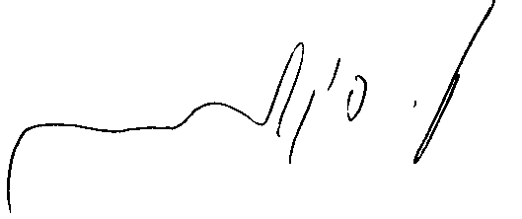
Sincerely,
Uzi Vogelman

