Internship report for the IASAJ Judge Exchange Programme:

|  |  |
| --- | --- |
| **Judge :**  Name : Grosskopf  First name : Ofer  Nationality : Israeli  Jurisdiction : Israel  Functions : Supreme Court Justice  Length of service : 13 years as a judge, of which 4.5 years in the supreme court. | **Exchange :**  Hosting jurisdiction : Portugal  Country : Portugal  City : Lisbon  Dates of the exchange : 12-22.9.2022 |

1. **Introduction – Presentation of the jurisdiction and the progress of the internship:**
2. *Programme of the exchange:*

****

*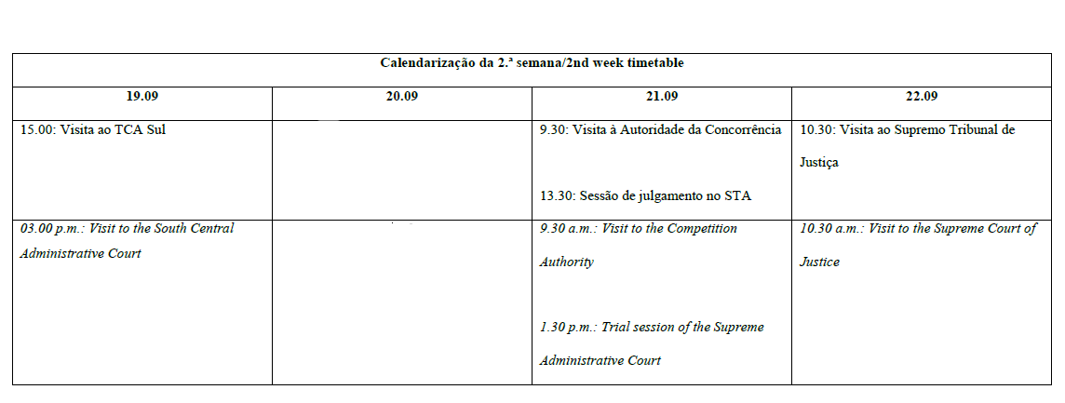*

1. *Presentation of the hosting jurisdiction:*

* *Member state of the European Union.*
* *Civil law jurisdiction with certain unique characteristic.*
* *Has a Constitution and a Constitutional Supreme Court (Tribunal Constitucional) since 1976.*
* *Has a well-developed 3 tiers administrative court system: courts of first instance; 2 Appeal Courts (North & South Central); Administrative Supreme Court (Supremo Tribunal Administrativo).*
* Portuguese administrative jurisprudence is distinctive, with considerable influences from the administrative jurisprudence of France and Germany.

1. **Differences and similarities between the legal systems of the country of origin and the host country:**
2. *Concerning the organization of the legal system:*

*Israel has a unitary court system, with one Supreme Court, while the Portuguese court system is divided into three main branches (Constitutional, Administrative and General), each headed by a distinct supreme court: the Constitutional Supreme Court; the Administrative Supreme Court; and the Supreme Court of Justice (Supremo Tribunal de Justiça).*

1. *Concerning the competence of administrative jurisdictions:*

*Israeli administrative court system is still developing, and has not yet reached its mature phase. In contrast, the Portuguese administrative system seems to be well developed, with a clear structure and a well-defined division of labour between the different instances.*

1. *Concerning the functioning of administrative jurisdictions:*

*Both systems seems to handle with success a considerable amount of administrative litigation. The number of judges in Portugal (both in general and in the administrative court system) is more than twice higher than the number of judges in Israel, but while Israeli judges has legal clerks to help them, Portuguese judges are required to do almost all their duties by themselves.*

1. *Concerning applicable procedures and rules of law:*

* *Israeli legal procedures includes oral as well as written arguments, while Portuguese legal procedures are based almost exclusively on written arguments.*
* *Israel, as a common law jurisdiction, follow the stare decisis principle, thus decisions of the Israeli Supreme Court serve as precedents for all lower courts. In contrast, Portugal, as a civil law system, does not follow the stare decisis principle, which may lead to some interesting conflicts.*

1. *Other aspects:*

*Israeli judges are appointed from the legal-bar after acquiring practical legal experience and without receiving special training to become judges. In contrast, Portuguese judges are selected straight after law school, and go through a 3 years academic program that prepare them for the judicial role.*

1. **Aspects on which the host country's legal system can be a source of inspiration for the country of origin (« good practice »):**
   * *The periodical process of evaluating judges based on their performance by fellow senior judges.*
   * *Special training program for judges before appointment.*
   * *A well-defined 3 tiers administrative court system, in which most (if not all) cases start at the court of first instance, appealed to the second instance, and are subject to appeal by leave (not by right) to the supreme court.*

**Signature:**

|  |  |
| --- | --- |
| *Judge:*  msotw9_temp0  Justice Ofer Grosskopf | *President / Chief Justice of the jurisdiction of origine:* |